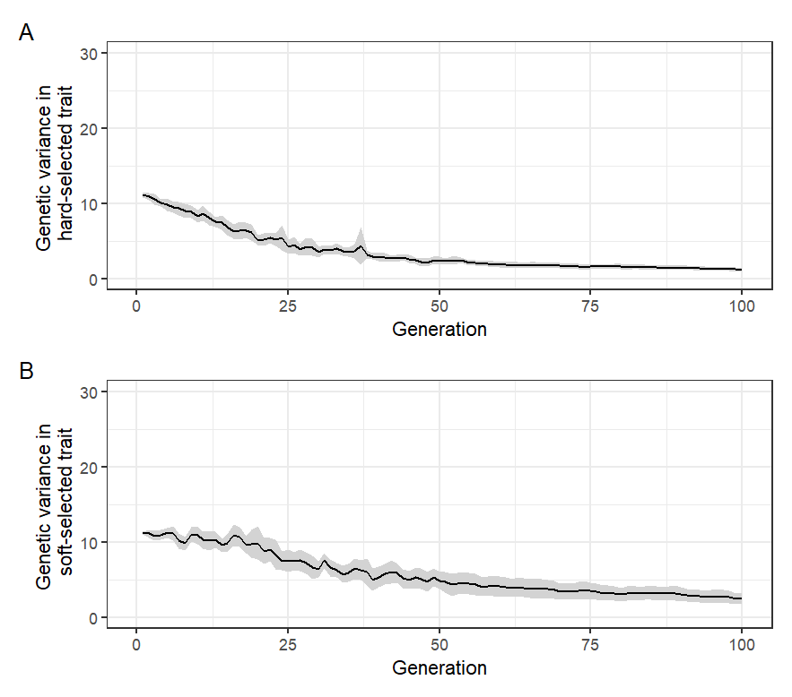

Fig.S1. Changes in additive genetic variance in (A) $Z_{HARD}$ and (B) $Z_{SOFT}$ over time in the baseline simulations set 2. Mean and 95% confidence intervals (grey ribbons) across 1000 replicate simulations shown.

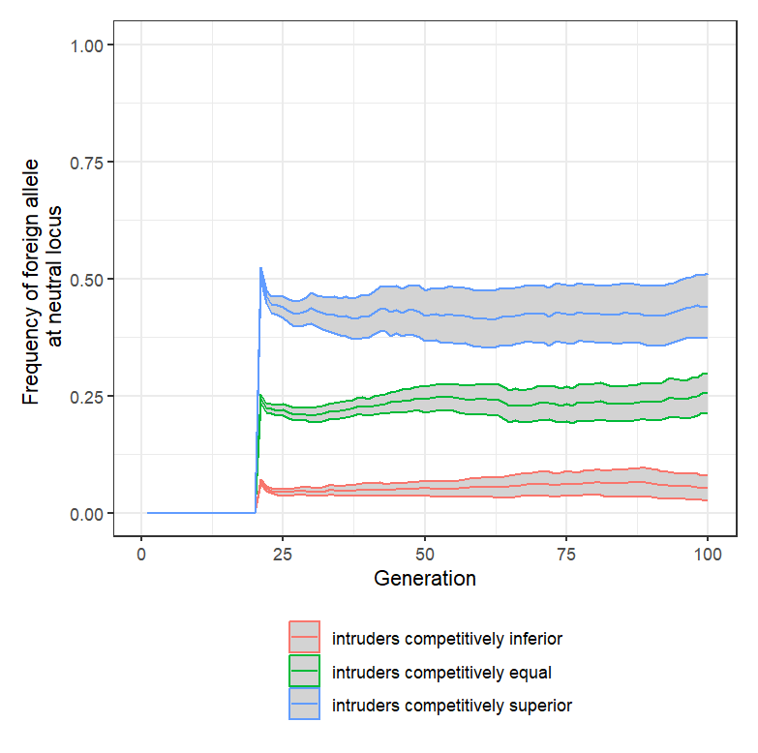

Fig.S2: Dynamics of introgression at the neutral locus in the acute intrusion simulations set 1. The y-axis shows the frequency of the foreign/domesticated allele at the single neutral locus. Mean and 95% confidence intervals (grey ribbons) across 1000 replicate simulations shown.

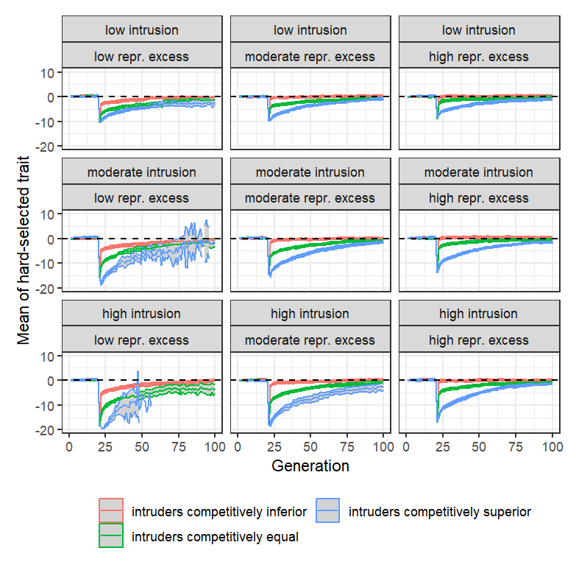

Fig.S3: The evolutionary dynamics of ${\overline{Z}}_{HARD}$ in the intrusion simulations set 2. $K$ =500 in all scenarios. Low intrusion = 250 intruders introduced in generation 20; moderate intrusion = 500 intruders introduced; high intrusion = 750 intruders introduced. Low reproductive excess: ; moderate reproductive excess: ; high reproductive excess: . Each panel shows the trajectory of ${\overline{Z}}_{HARD}$ over time, with the average taken each generation over only those replicate populations that persisted ($N_{S}>0$). $h^{2}(initial)$ = 0.25.

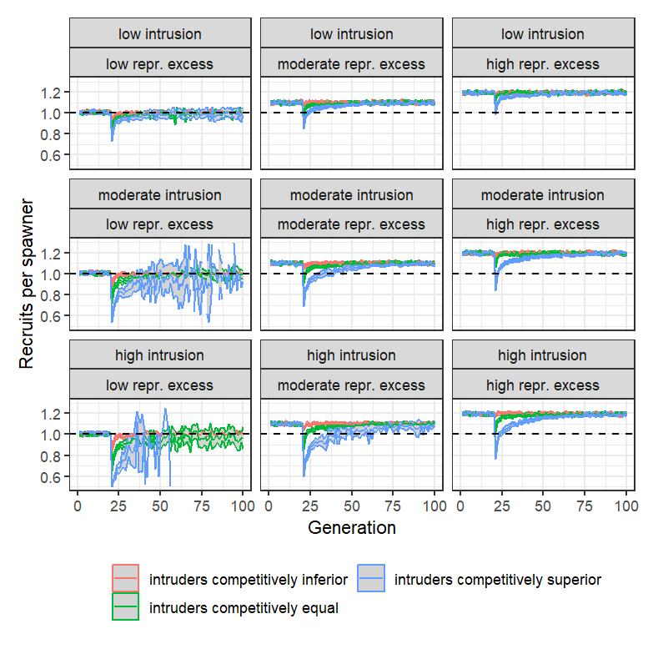

Fig.S4: Changes in $RPS$ in the one-off intrusion simulations set 2. $K$ =500 in all scenarios. Low intrusion = 250 intruders introduced in generation 20; moderate intrusion = 500 intruders introduced; high intrusion = 750 intruders introduced. Low reproductive excess: ; moderate reproductive excess: ; high reproductive excess: . Each panel shows the trajectory of $RPS$ over time, with the average taken each generation over only those replicate populations that persisted ($N_{S}>0$). $h^{2}(initial)$ = 0.25.

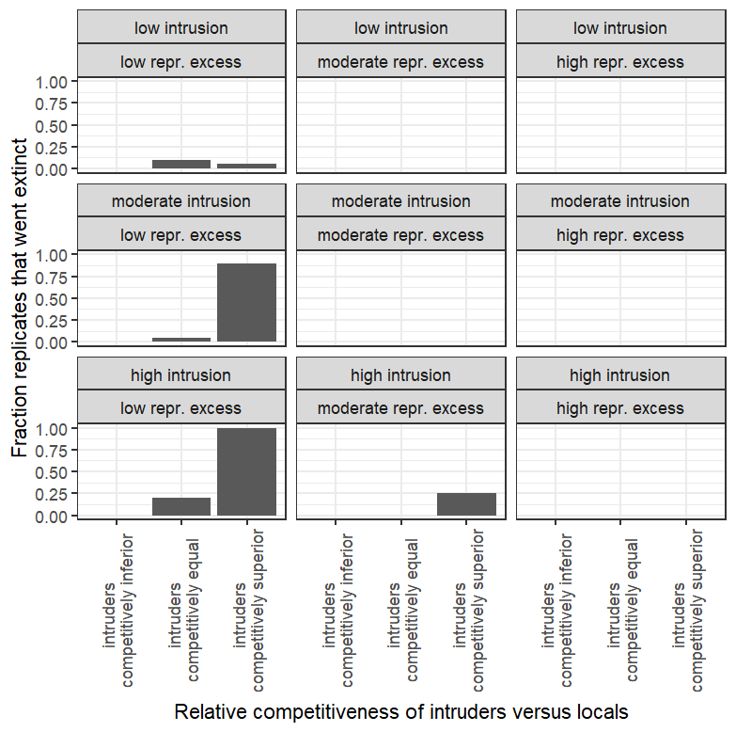

Fig.S5: Probability of extinction in the one-off intrusion simulations set 2. $K$ =500 in all scenarios. Low intrusion = 250 intruders introduced in generation 20; moderate intrusion = 500 intruders introduced; high intrusion = 750 intruders introduced. Low reproductive excess: $W_{MAX}=0.53$; moderate reproductive excess: $W_{MAX}=0.58$; high reproductive excess: $W_{MAX}=0.63$. $h^{2}(initial)$ = 0.25.

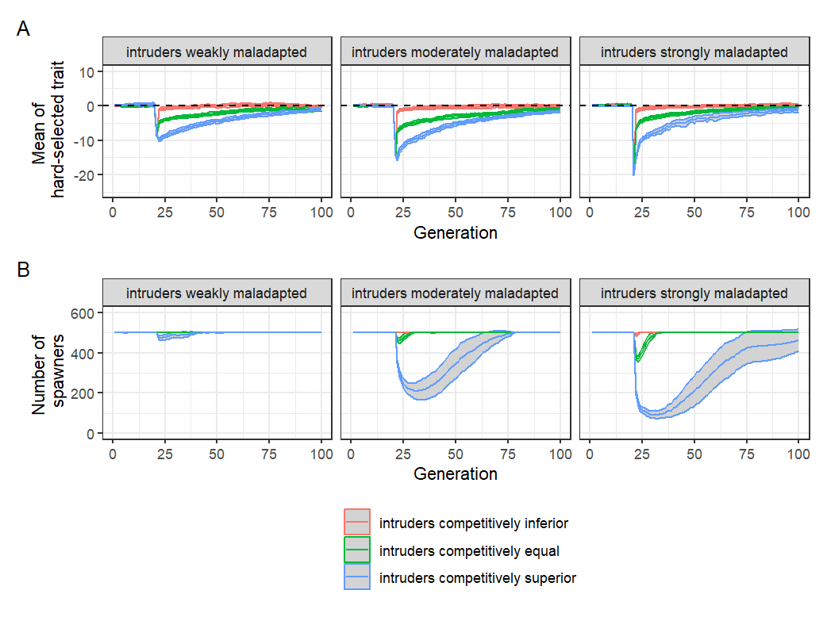

Fig.S6: Effects of level of maladaptation of intruders on the results of one-off intrusion simulations. (A) Evolutionary trajectory of $Z_{HARD}$. (B) Number of spawners through time. Mean and 95% confidence intervals across 1000 replicates shown. In all cases, a moderate level of one-off intrusion (500 intruders introduced at generation 20) and a moderate level of reproductive excess ($W_{MAX}=0.58$) was assumed, with $h^{2}(initial)$ = 0.25.

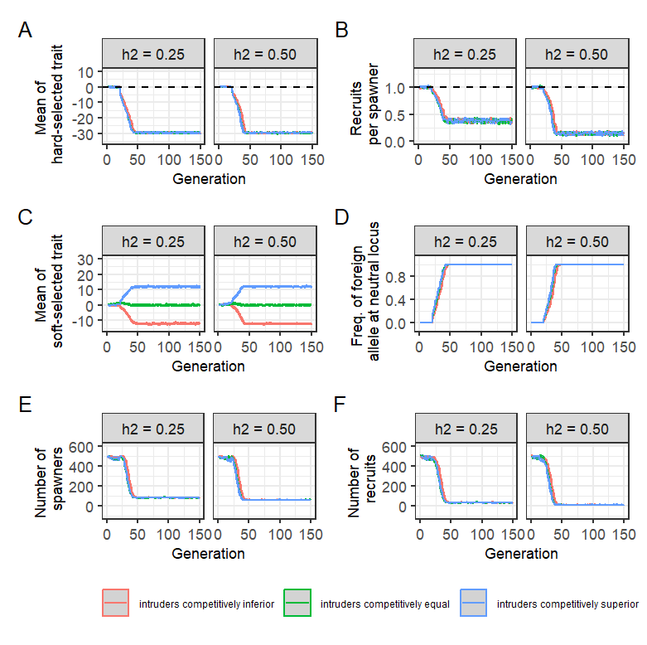

Fig.S7: Results of continuous intrusion simulations set 3 for the low reproductive excess scenario ($W_{MAX}=0.53$). Each panel shows the results (mean and 95% confidence intervals across 1000 replicate simulations) comparing cases where the initial heritability of both $Z_{SOFT}$ and $Z_{HARD}$ was $h^{2}\left(initial\right)=$ 0.25 (left sub-panels) or $h^{2}\left(initial\right)=$ 0.50 (right sub-panels). The per-generation intrusion rate was fixed at 10% of $K$, i.e., 50 foreign/domesticated fish intruded each generation.

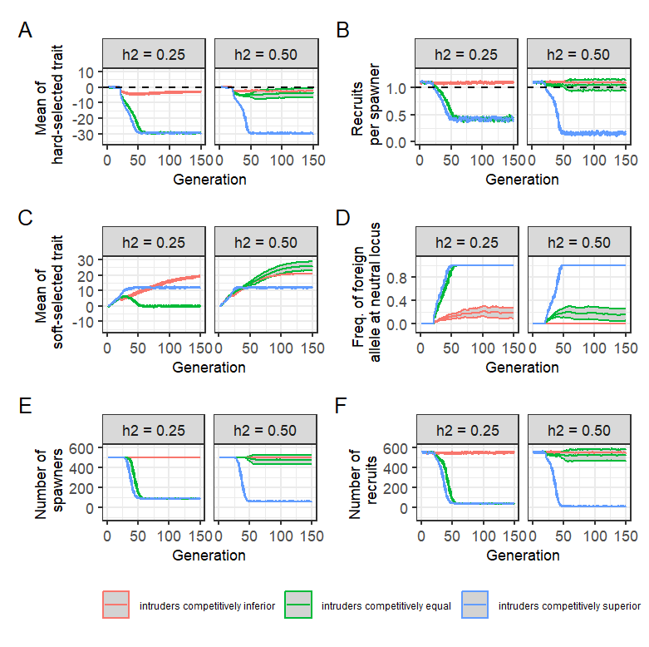

Fig.S8: Results of continuous intrusion simulations set 3 for the moderate reproductive excess scenario ($W_{MAX}=0.58$). Each panel shows the results (mean and 95% confidence intervals across 1000 replicate simulations) comparing cases where the heritability (h2) of both and was 0.25 (left sub-panels) or 0.50 (right sub-panels). The per-generation intrusion rate was fixed at 10% of $K$, i.e., 50 foreign/domesticated fish intruded each generation.

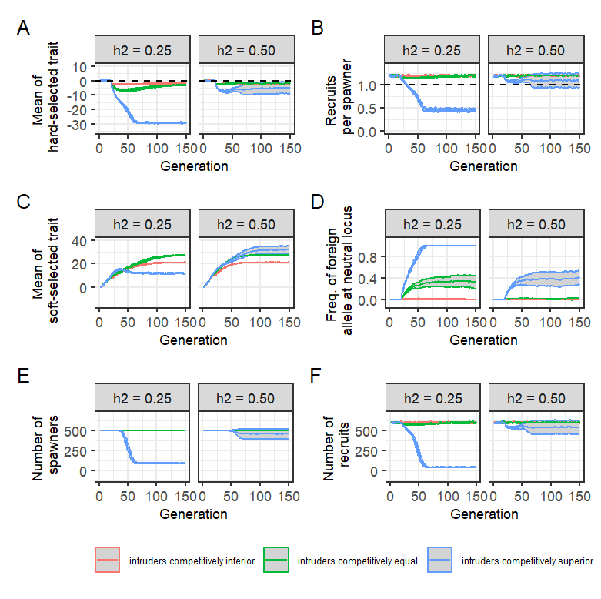

Fig.S9: Results of continuous intrusion simulations set 3 for the high reproductive excess scenario ($W_{MAX}=0.63$). Each panel shows the results (mean and 95% confidence intervals across 1000 replicate simulations) comparing cases where the heritability of both $Z_{SOFT}$ and $Z_{HARD}$ was $h^{2}\left(initial\right)=$ 0.25 (left sub-panels) or $h^{2}\left(initial\right)=$ 0.50 (right sub-panels). The per-generation intrusion rate was fixed at 10% of , i.e., 50 foreign/domesticated fish intruded each generation.